AWS Solution Architect

Index
HA | High Availability
MAZ | Multiple availability zone
1AZ | Single availability zone
DX | Customer Data center
ASG | AutoScaling Group
DDB | DynamoDB

Architecture

OSI
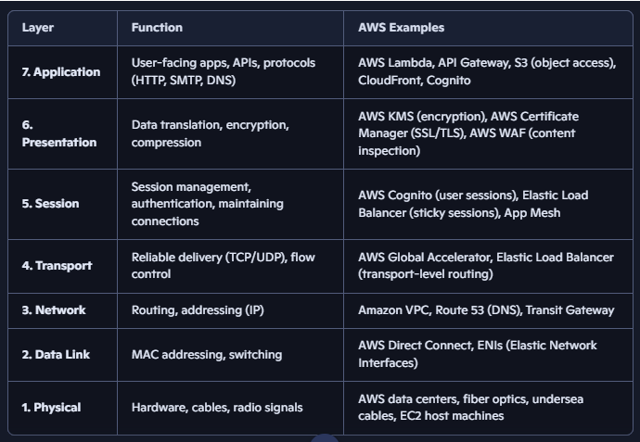
 | Protocols | Networking | Services
Application | HTTP  Communicates on the reliable connection made by TCP |  |  | Alb  Fwds reqs to services based on what’s requested
Presentation |  |  |  | Manages data processing incls. encryption
Session |  |  |  | Manages the stateful sessions  - Retains the memory |  | Eg: chatbot
Transport | TCP  UDP |  | Security Groups (Virtual firewall)  IP based – Network lyr  Port/protocol based – Transport lyr |  | nlb  Fwds traffic to Target groups based on IP/Port
Network

Application
Presentation
Session
Transport
TCP:
- Makes a reliable connection bw systems on which HTTP communicates
Network

Networking Layer
Layer | Typical Entry Points / Controls | Authentication / Authorization | Purpose | Other Considerations
Network | Internet Gateway, VPN Gateway, Transit Gateway, VPC Peering, Direct Connect | VPN Credentials, MFA, Client Certificates, IP Allow Lists | Enter or connect networks | Routing, Network Segmentation, Cross-VPC Connectivity
Subnet | Route Tables, NACLs | No user authentication; traffic allowed/denied based on IP, Port, Protocol | Control traffic flow into/out of subnets | Public vs Private Subnets, East-West Traffic Control
Component / Service | Load Balancer, API Gateway, Ingress, EC2, Pod, RDS, Redis, Kafka, Service Mesh | TLS, mTLS, API Keys, JWT, IAM, RBAC, DB Credentials, SSH Keys, Security Groups | Reach a specific service or resource | Service Discovery, Rate Limiting, WAF, Service-to-Service Security
Application | Web App, REST API, GraphQL API, Microservice Endpoints | Username/Password, OAuth, OIDC, JWT, Session Cookies, Roles, Claims | Perform business operations | Fine-Grained Authorization, Audit Logs, Business Rules

AWS Basics

AWS regions:
- Places are divided into regions and within each region we’ve 3 AZ ensuring resilience
Snapshots – snapshots are incremental only the changes are stored in the nextcoming snapshots – helps in huges data storage saving.

IAM
IAM User
- Username & Password – login to console and use AWS
- IAM Access key – used by VM/application code to use AWS resources/services.
IAM Role
- Services:
- Services inside AWS account: role assumed by a service to connect with other AWS Services
- Services outside AWS Account: first get authenticated to assume a role
- temporarily assumed by users for cross account, elevated privilages.
Inline policies – policies directly attached(hardocoded) to the user
IAM Policies structure

AWS CLI & SDK
AWS CLI
- Direct access to the public API of AWS services through CLI
AWS SDK
- To use AWS services intergratedly within the application code

IAM reports
Credential report – report of IAM users in the account
Last access – to check what are the services accessed by a user – helps in granting least access.

Summary
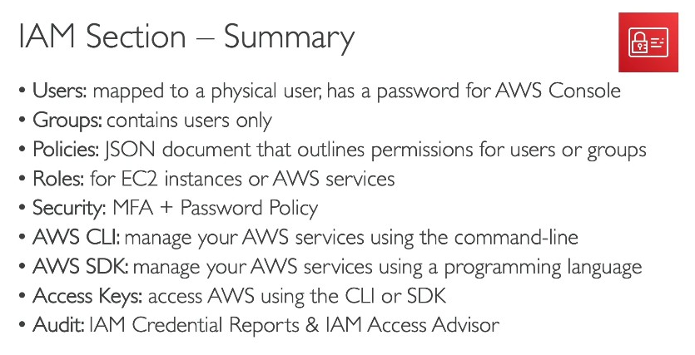
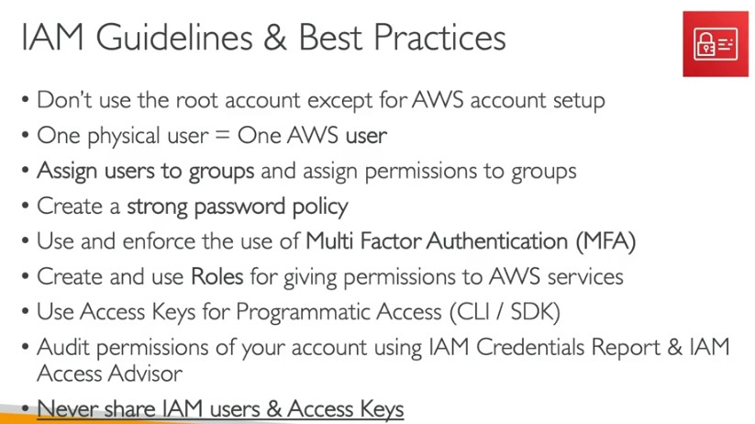

Activities → Major Tools
Activity | Purpose | Major Tools (Linux + Cloud)
Package Management (install/update software) | Manage software packages and dependencies | YUM/DNF (RHEL, CentOS, Amazon Linux), APT (Debian/Ubuntu), Zypper (SUSE), Pacman (Arch)
Service Management (keep it running) | Start/stop/restart services, manage daemons | systemctl (systemd), service (SysVinit), chkconfig (legacy), AWS System Manager Run Command
Monitoring/Logging (know when it breaks) | Observe system health, collect logs, detect failures | top/htop, ps, journalctl, sar, Nagios, Prometheus + Grafana, AWS CloudWatch, Dynatrace, New Relic, Kibana
Security/Patching (keep it safe) | Apply updates, enforce firewall rules, secure access | yum update --security, dnf update, iptables, firewalld, SELinux, AppArmor, AWS WAF, IAM, Systems Manager Patch Manager
Automation (scale it across fleets) | Automate provisioning, config mgmt, deployments | cron, Ansible, Puppet, Chef, Terraform, Jenkins, GitHub Actions, AWS CloudFormation, CodePipeline, Lambda

Compute Layer

EC2
- Cores & vCPU
  - w/o hyperthreading - 1 core = 1 process at a time (context switching for multitasking).
  - With hyperthreading – 1 core = 2 vCPUs = 2 processes at a time(each with it’s own context)
- Comparing EC2 Instances: Amazon EC2 Instance Comparison

✨Buying EC2
- On demand – pay as u go pricing
- Reserved – paid on a tenure basis
- Spot intances – cheaper – buying based on availability
  - average interruption is <10%
based on:
- tier - OS, CPU compute capacity & CPU cores, RAM
- Storage
  - Attached storage(through network) – EFS, EBS
  - Hardware builtin storage – EC2 instance store
- Network card
EC2 user data: used to bootstrap the instances.

✨Topologies/ EC2 Placement groups
Cluster | all instances are placed together in a rack | High connectivity -> low latency -> High performance
Partition | Set of instances/racks are partitioned from others  (Into single AZ – high connectivity for high distributed systems) | Medium connectivity, Fault isolation
Spread | placed in diff AZs  (supports upto 7) | Lesser connectivity, High availability & Fault tolerance

Security Groups
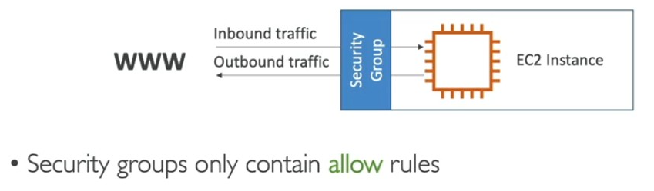
- Stateful (only contains allow rules)

SG wrt OSI Layer
IP-based SG rules = Network Layer.
Port/protocol SG rules = Transport Layer.
- Together, Security Groups act as a stateful firewall
Stick to AZ – Network related provisions are sticked to the AZ (location based) can’t be accessed beyond the location.
- NIC, Elastic IP, EBS

Hibernating - EC2 Hibernate
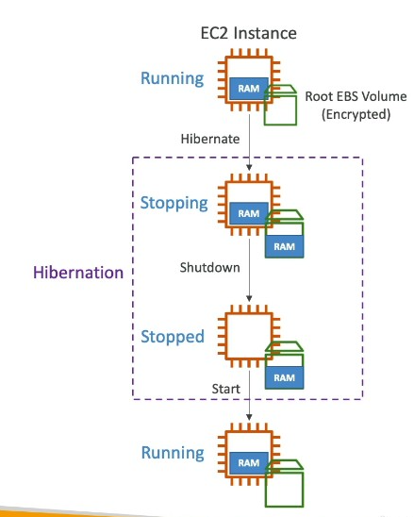
- RAM contents (running processes, memory state) are saved to the root volume (EBS)
- For Memory Intensive, Stateful Applications: ML & Big Data analytics, Dev/test envt

AMI
AMI – Customized image for an EC2 instance – with all the prepackaged Software configurations for the application
- base snapshot
AWS Marketplace AMI – Ready made AMI will be available to buy.

Load Balancer
(in AWS – ELB- all types of load balancer)
Works on: | ALB  - lyr7 | NLB  - lyr4(Transaport layer) | GWLB  - lyr3(NW lyr)
Target: | forward traffic to application/microservice | To Server/pod | To include a firewall and forward to it.
 | path based routing on http/s | just forwards it to any of the servers from TG  Creates TCP connection between 2 systems and transmits the traffic | To include 3rd party appliances(security appliances) in the traffic flow

ALB
- In ALB Requests coming to a certain port are directed towards a target group
  - Instances can be modified to accept requests only from the ALB Security Group.
  - Listener rules: request with a specific header/ path/ .. will be directed to target group/URL/fixed response(with a response code)
  - 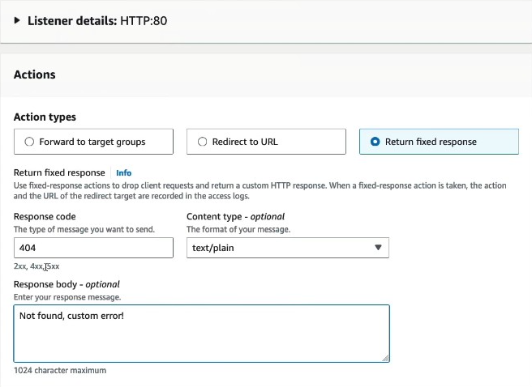

Demo ALB
- [Instances ] attached to Target Group connected to ALB with both TG & ALB SG set acc.
  - ALB facing the internet accept requests in http(port 80) & https(port 443) forwards the traffic to Target group SG.
  - The target group SG also set in a way, it accepts reqeuests only ALB SG and outboud: any.

NLB
- Forwards the TCP packets(HTTP/S, SMTP, DNS,..) to instances.
- Instance will take care of interpreting the HTTP/S and responding to them

GLB
- All the traffic goes through the GLB then reaches the destination.
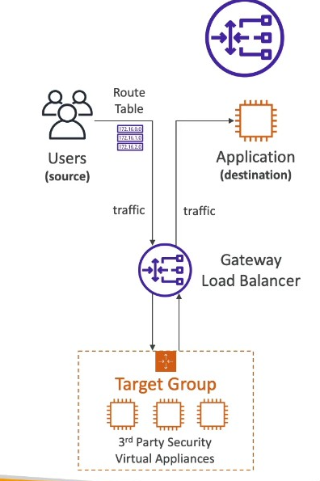
- Analyses the traffic received from users and drop it(if…)

ELB Stickiness
- Routes traffic from a specific user to a specific instance all the time – Manages the session
- ** Has more to go on regarding sessions and tls certificate

Autoscaling
- Can be managed with cloudwatch alarms and scaling.
Dynamic Scaling: AWS creates/manages the necessary CloudWatch alarms bts.
  - Target Tracking scaling: eg: keep the Total ASG CPU usage at 40%
  - Simple/step scaling: On alarm trigger – cpu>70% : inc 1 instance
Scheduled Scaling: Upscaling/ downscaling the instances on a scheduled time
Scaling Scenarios

Hosting
Lightsail – for small light weight applications
EC2 –
ECS Fargate – automatic management of servers based on memory, compute,..
EKS – maintenance heavy

Maintenance
Applying patches on an EC2 instance in production: standby

Storage
S3 | EBS | EFS | Instance Store
For unstructured data | Attached to single-instance*, low-latency workloads like database(self managed DB). | shared file access - across multiple instances | Physically attached to the EC2 instance – Losing the instance -> Instance Store, memory will also be lost.
For backup, media | 1AZ | MAZ | for temporary data storage – Cache, buffer.
Access:  API calls | Mounted as a drive | Mounted as a drive(linux file system) using NFS

S3
Stores all the data in the form of objects in buckets – Globally unique, durability: 11 9s.
Access: provided on 2 levels
- IAM User policy – user based access, role based access.
- Bcucket policy
- By default, Bucket – public access is blocked
  - Enabling the public access – it can be custom configured
Supports object level Versioning
- Versioning also prevents deletion of the object.
Replication: Only new objects are replicated not the existing ones
- Same region replication – live replication
- Cross region/cross account replication – async replication
- Needs:
  - Both S3 devices have to be versioning enabled
  - Both Should have enrolled IAM role to communicate
Transfer Rate: at least 3,500 write or 5,500 read requests per/s per prefix(folder) in a bucket.
- It’ll be increased parallely by having as many folders.
S3 Std | S3 Std IA | S3 Glacier
Usecase: To access media, files, general use case | Not frequently accessed | Rarely accessed(Archieved files)  Stores records and logs
Cost: high | Low | Lower
Min storage duration: | 30 days | 90 days

S3 |  | S3 std |  |  | S3 std IA(infrequent Access) | S3 1AZ IA
Frequency |  | Frequent |  |  | Infrequent | Infrequent
Cost per GB Storage  Cost per GB retrieval | High cost per gb storage |  |  | < high  Higher cost per gb retrieval |  |  | Higher cost per gb retrieval  Data will be in 1AZ
Use Case | General |  |  | Disaster recovery, backups |  |  | Secondary backups
Lifecycle Policy – move data after a certain period of time
S3 Integlligent tiering – Access pattern is unknown, unpredictable --> monitoring the access pattern and moves our data in bw s3 std & s3 std IA, to help us in cost saving.

S3 std S3 std IA S3 glacier instant access Deep Archive access
Unaccessed for: (30 days) (90 days) (700+ days)

S3 Express 1AZ – lowest latency

S3 Glacier  (To store archived files)  Price – storage + retrieval cost  Analytics data(not been used regularly) |  |  | Instant retrieval | Flexible retrieval –  Expedited (1 to 5 mins)  Standard (3 to 5 hours)  Bulk (5 to 12 hours) |  |  | Deep archive –  Std (12 hours)  Bulk (48 hours)
Retrieval Time |  |  | In milliseconds | In mins to hrs |  |  | Within 12 hrs
Cost |  |  | Low | Lower |  |  | Lowest
Storage duration |  |  | 90 days | 90 days |  |  | 180 days

S3 Encryption
At rest encryption - Data is encrypted before transition (CSE) or after transition (SSE)
In Transit encryption – TLS Encryption – Generally any request(includes both request and data) in HTTPS is encrypted during transition in the network
- To avoid Unencrypted reqs(HTTP reqs) reaching S3 bucket

Client side encryption
- Client side encryption(At rest encryption): Client encrypts the data on their side(enc key managed by clients) then uploads it in bucket

Server side encryption
- Basic Encryption(Default encryption): S3 - SSE S3(Default)
- Upload file with header "x-amz-server-side-encryption": "AES256"
- ✨S3 encrypts it with the S3 owned key and puts in bucket
  - Each object is uniquely encrypted and can’t be used for audit trail(who’s performing the encryption and when)
- Production Grade Encryption: with key stored in KMS
- Upload file with header "x-amz-server-side-encryption": "aws:kms"
- S3 encrypts it with the KMS key and puts in bucket
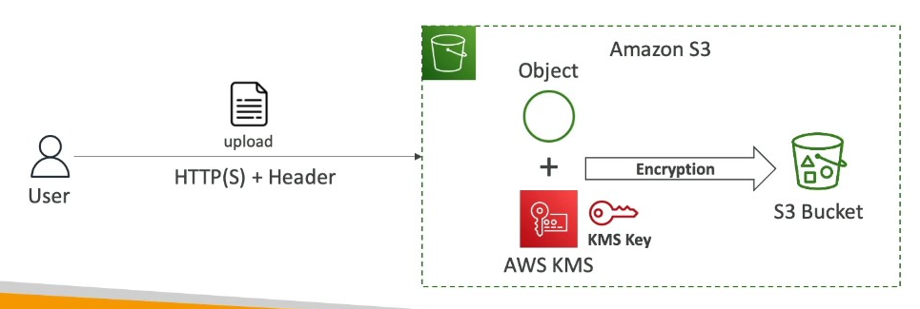

- Customer Encryption: with customer provided key
  - S3 encrypts the object based on the encryption key provided by Customer

CORS: Cross Origin Resource Sharing
If the requested data isn’t available in the server it redirects the request to another server. That cross orgin server works on the
CORS Policy:
Access control allow origin & allow methods
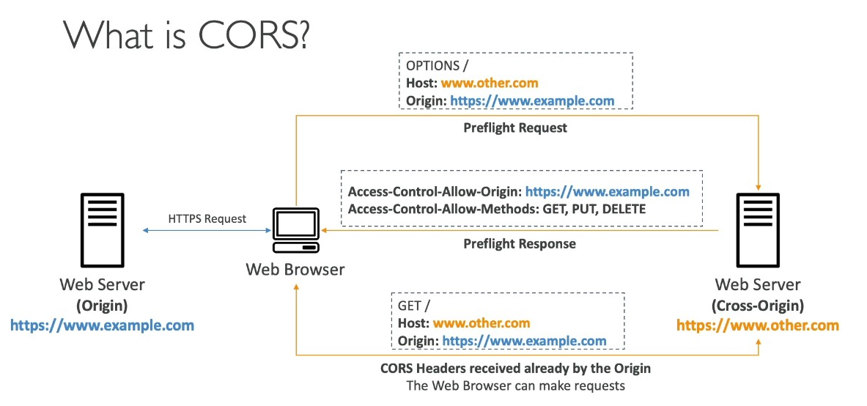

Adv S3
Batch operations: performing activity like encryption, replication on a group(batch) of S3 objects
Event notification: S3 can be integrated with SNS, SQS, Lambda, Event bridge-any actions on S3 can be used as an event/trigger.

Faster Data Transfer to S3
S3TA - S3 Transfer Acceleration:
Normal S3 Transfer: user(data)----> S3 Bucket
S3TA: user(data) ----> Cloudfront’s Edge location --(optimized network path)--> S3 Bucket
Multipart upload:

Attachments
File gateway: NFS compatible interface to on-premise setup, helps in uploading the data to S3 without making any changes to the NFS setup

EBS
- Block storage attached to an instance; one/many to one*
- To move the EBS content from one AZ to another AZ: EBS(AZ1) -> EBS Snapshot -> EBS(AZ2)
- EBS Snapshot: moving snapshot to the archieve tier is a cost saver.
- EBS Encryption: to create an encrypted EBS volume from Unencrypted EBS volume:
  - take snapshot of EBS -> Encrypt the Snapshot -> Create EBS vol from the snapshot
EBS Volume types
SSD | gp2 | Transactional workload | For dev - General workloads |  | $
SSD | gp3 | Transactional workload | For dev - General workloads | IOPS increased indeply | $Default choice✅
SSD | io1 | Transactional workload | For DBs - High IOPS(IOPS incd independantly),  Supports 1 EBS to many EC2(upto 16 instances) ltd to 1 AZ. |  | $$
SSD | io2 | Transactional workload |  | High durability | $$$
Hard Drive | st1 | Large streaming workload (High Throughput reqt) | Big data - memory per request: max- 1MB |  | $
Hard Drive | sc1 | Large streaming workload (High Throughput reqt) | Big data - memory per request: max- 1MB | infrequent access(cold) | Lowest

- gp2, gp3: General Purpose SSD – High IOPS| UseCase: for dev envt,..
- io1, io2: High performance SSD– Ultimately High IOPS | *Supports muti attach EC2: one to many EC2(upto 16 instances) ltd to 1 AZ.
  - memory per request: max- 16KB | for both gp & io
gp2 | IOPS incs with disk size (IOPS locked to disk capacity)
gp3, io1, io2 | IOPS can be increased independently wrt disk size
- sc,st: memory per request: max- 1MB

AMI developed with Snapshot
- AMI stores the configuration of the server
- All the data[OS files,..] the server required will be stored in the Snapshot(EBS Volume)

EFS
- Elastic File system shared across multiple instances in multiple AZs

EC2 Instance Store
- Better Read/Write compared to EBS
- If the storage is stopped, it’ll lose all the data
  - Best for temporary data storage – Cache, buffer.

Databases

RDS

Replicas
- Upon writing data to replica if it’s acknowledged sync replicas o/w async replicas
Sync replicas – main DB server writes to the standby replica DB and acknowledges that data’s been written in
Primary server blyk~ are you done or not.. tell me now
Async replicas - main DB server writes to the standby replica DB and Don’t care
Primary server blyk~ Not my problem
Restore - Stopping storage/DB for long time costs the same – better take snapshot, del the DB and restore from snapshot
Cloning – DB clone will be created from the main DB volume | copy and write | faster than restore
DB Encryption – has to be done while launching the DB
- Take a snapshot of the DB and launch the snapshot with encryption enabled
RDS Proxy in AWS – manages connection pooling | Serverless, Autoscaling, HA(MAZ)
- Reduces failover time upto 66%
- Enforces IAM authentication
- Not puclicly accessible
Amazon RDS Custom: provides specialized customization of DB & the underlying OS
- Main purpose: to support legacy applications
- Supports: Oracle, SQL Server

Aurora
- HA (6 Read instances across 3AZ) + automatic failover + AS
Other DBs | Aurora – fully AWS managed like a cluster
DB server + Storage = DB | Writer/Reader + storage layer = Aurora DB
DB Server & Storage lyr are integrated together, so in multiple regions, we need to implement/deploy multiple DBs | Writer in Primary region  Reader in all global regions as reqd,  Storage lyr is separate from writer&reader  2 copies of storage disk is available in all 3AZs of regions.

- Writer endpoint, reader endpoint – provides a constant connection to the DB
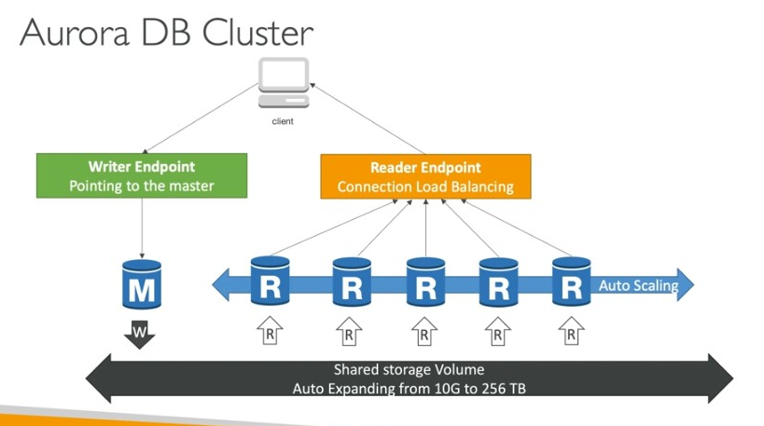

Elasticache
Redis | MemCached
Persistence | Nope  “who the hell told you to trust me on data..
Has many Data structures | Strictly string, stores key-values

DynamoDB(DDB)
DynamoDB – suitable for the DB schema which evolves rapidly and enormously(horizontally)
- Data limit per row: 400kb
R/W capacity:
2 kinds
- Provisioned mode – Read & Write capacity (RCU, WCU) is provided as defined
- Autoscaling mode is available to increase the R/W capacity(scaling in Provisioned mode is slower than On Demand mode)
- On Demand mode – for rare amt of traffic or steep curves
- scaling is handled by AWS

Adv DDB

DAX(DDB Accelerator)
- memory cache for DDB reduces read congestion
DAX Vs Elasticache:
DAX – to store simple results/fetches from the DDB (individual objects cache, query cache, scanned query cache)
Keywords: DDB, API compatible
Elasticache – to store heavy computation results.
Keywords: Real time transactions, analytics & cache, chat/messaging, ML, leaderboards

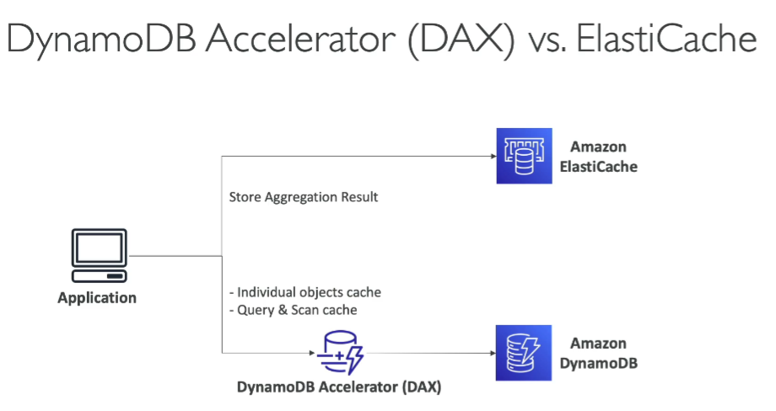

DDB Streams
- for stream processing
DDB Streams – Ltd(24 hrs retention, ltd # of consumers)
- Can be connected to AWS Lambda trigger, DDB Stream Kinesis Adapter.
Kinesis Data Streams – Adv(1 yr retention, more # of consumers)
- Kinesis data analytics, data firehose, AWS Glue ETL
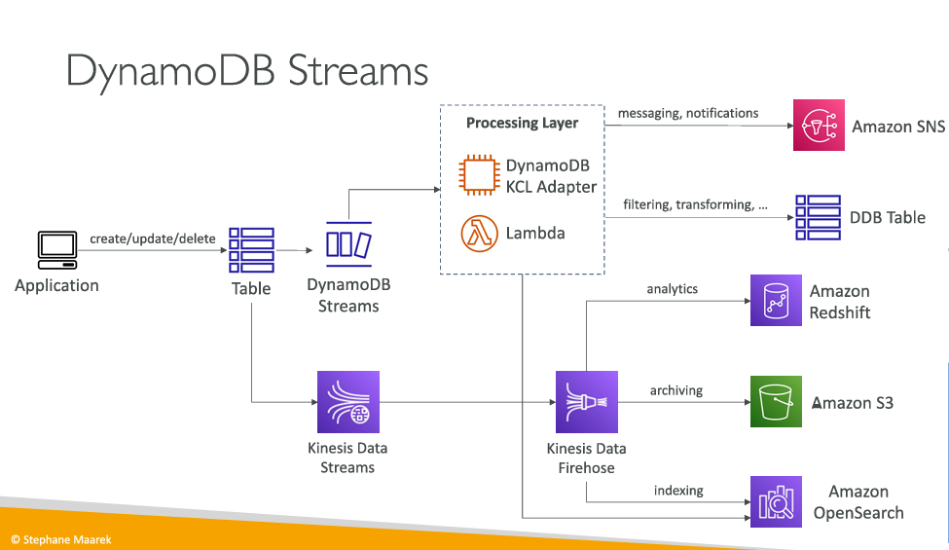

DDB Global Tables
- DDB deployed in multiple regions, data written to 1 region is updated/replicated in other regions through internal DDB Streams(internally managed by AWS).
- DDB Streams lead to eventual inconsistency(MREC Vs MRSC)
DDB TTL
- Data stored in DDB will be deleted after a specified TTL
- What’s the need to delete data stored in DDB ?:
  - Web session handling – when user logs in, a web session will be created, that session should be deleted from company’s database in 2 hrs as per the organization policy if the user doesn’t login again in the 2 hrs. In such scenarios DDB TTL can be used to delete data from DDB.
DDB Backups
- Continuous Backup with PITR for last # no. of days
- On Demand Backup
- Integrated with S3 – Export to S3/Import from S3
  - Data from DDB will be exported to S3, use Athena for Data analytics, use ETL and import back to DDB in diff format.

Databases II

Database Types
RDBMS/SQL:
- RDS: postgresql, MySQL, Oracle, SQL Server, DB2, Maria DB
- Automated backup with PITR(within 35 days)
- RDS Custom: to support legacy applications – adv configuration of DB
- Aurora: postgresql, MySQL
- Aurora serverless: for rare intermittent spikes
- Aurora Global: upto 16 read instances in each region
- Aurora ML: perform ML using Sagemaker
- DB Cloning > DB Restore
NoSQL
- DynamoDB (JSON)
- Serverless, scalable, HA, fully managed by AWS DB.
Use case: serverless apln development, distributed serverless cache.
- Document DB (MongoDB): efficient for ad-hoc querying of JSON documents
- Elasticache (Redis, memcached) - in memory data store(for read and fast lookup/access): RDS for caches
  - Requires code changes
  - Stores Key-Value pairs X Sql quries can’t be applied
- Keyspaces (Apache Cassandra)
- llly to DynamoDB
use case: IOT device info/data, time series data
Graphs
- Neptune: Graph database – displays relationship between data, for social network
- HA across 3 AZs with 15 ReadReplicas.
- Neptune Streams:
- Any update in Neptune graph database will be recorded(in ordered sequence) in neptune streams, can be used as a trigger through neptune streams
  - To update in Neptune DB in other regions
  - Trigger to store in other datastores: S3, elasticache,..
  - Trigger event driven functions

Amazon timestream: time series database
- Moves older data to cost optimized storage
Recent Data (Memory Store)
|
|
\/
Older Data (Storage)
- Usecase: to store any data wrt time eg: server usage @ time, IOT devices.
Comparisons:
RDS→ Business transactionss
DynamoDB→ Fast key/value lookups: better for query based on primary keys/indexes
DocumentDB→ JSON document queries: better for query based on all the json values
ElasticSearch→ query any fields from JSON( incl. partial matches): performs analytics on top of queries
Timestream→ Timestamp-based metrics and events

Search
- opensearch
Ledger

Object store: S3
Data warehouse
- Redshift
- Athena
- EMR

Database(RDS, Dynamodb, Neptune,..) Vs Data warehouse(Redshift, Athena) == OLTP Vs OLAP

Data & Analytics

Data Warehouse

Athena
- Serverless query service, performs analytics on data stored in s3 @ 5$ per TB.
- Used with Amazon quicksight for creating analytics dashboard
- Usecase: serverless querying and analysis on S3 data, logs(all kinds of logs)
Performance Improvement
- Data in parquet format(columnar data format), partitioned format(in S3) helps in retrieving the specific reqd data.
  - Data trasnformation tool: AWS Glue can be used
- Compressed data format helps in less retrival_data_size
- With Data source connectors on Lambda, run federated queries to collect data from all kind of DBs – SQL, NoSQL, elasticache, on prem DB servers,..

Redshift
- Based on postgresql, OLAP, columnar storage.
- Redshift = Leader node + compute nodes + Redshift columnar storage(with data distributed across nodes)
- Provisioned mode - leader node(plans the query and passes/commands the compute nodes) + compute nodes(performs the query and send the result back to leader node)
- Provides reserved instances for cost saving.
- Serverless mode – AWS takes care everything
Feeding data into Redshift
- Kinesis data firehose: collects data from all sources and keeps it in S3, then copy it to Redshift
- S3 to Redshift: manually copy data to Redshift
  - Through internet
  - Through enhanced VPC routing: data doesn’t travel through internet, data travelled within the VPC.
- EC2 instance to Redshift: instead of writing data to Redshift row by row, we’ve to upload data to Redshift in batches.
Data Recovery
- MAZ available for some clusters
- remaining we can take snapshots(of an entire cluster), can be deployed in another region.
Redshift spectrum: serverless compute layer between worker nodes & S3 storage.
- As a middleman, avoids fetching all the data from S3 to Redshfit storage layer and queries only the required data from S3 and performs analysis.
Labs: Athena Lab

Athena Vs Redshift
Performs querying/analysis directly on s3 | Brings the data to Redshift cluster and the performs analysis
Serverless | Dedicated analytics warehouse

OpenSearch/ElasticSearch
- Query data based on any field in JSON(incl. partial matches) (DDB queries on primary keys/indexes) and performs analytics on top of queried data (which DocDB can’t do)
- Opensearch Dashboard: to visualize the analytics data
Architecture: General architecture pattern is data from DDB/logs/.. is written to OpenSearch through lambda function/ kinesis data firehose.
So data can be read from openSearch using partial matches along with data’s id. With the id we can fetch the data from DDB.
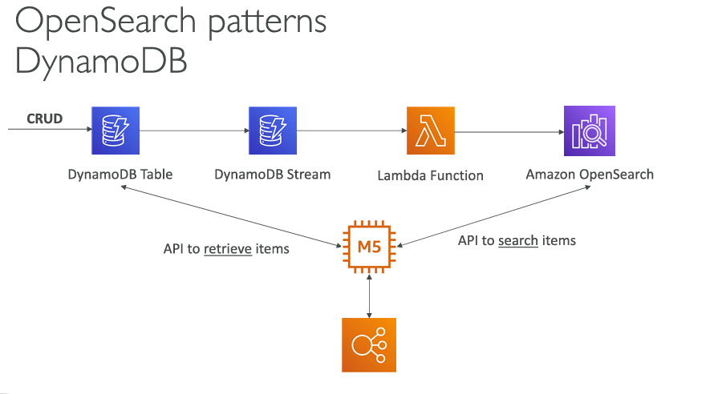

EMR: Elastic Map Reduce
- Data processing tool
Technologies supported by EMR: Hadoop, Hbase, Presto, apache,..
Nodes:
- For long running
  - Master node: manages cluster, performs tasks and stores data
  - Core node: performs tasks and stores data
- For temporary tasks
  - Task node: performs tasks
Buying options: On Demand, Reserved, Spot

QuickSight
: Serverless BI Service to create interactive dashboard
Supports InMemory computations with SPICE engine, for the data(Excel, pdf,..) directly fetched into quicksight
Integrations:
- AWS services: Data storage(S3)/DB(RDS, Aurora)/Data wareshouse(Redshift, Athena)
- 3rd party services, on Prem Data stores
- Data(Excel, pdf,..) directly imported into quicksight
Managing access to Quicksight dashboards: users and groups can be created in quicksight and provided access to dashboards

AWS Glue
: ETL tool
Glue Data Catalogue: Glue crawlers crawl on the data sources to fetch it’s metadata and store it in Glue catalogue
- Catalogue will be used other services: Athena, Redshift,.. for data discovery and processing.
Glue
Job bookmarks,
Databrew: cleans and normalizes the data
Studio: GUI
Streaming ETL: performs ETL on streaming data rather than batched data.

AWS Lakeformation: Built on top of AWS Glue to create data lake
Data lake: central place for all the data to perform analytics,
lake formation – helps in moving data(with collecting, cleaning, moving, cataloguing,..) from all the data sources to Data lake
- Built on top of AWS glue, all the data is stored in S3.
Blue prints – helps in moving data from Data sources (S3, SQL, NoSQL,..) to Data lake
Advantage/Benefit: to create data lake and helps in managing the security(Row/column level) centrally for all the connected services

Flink: framework for processing data streams
Amazon managed service for apache flink: aws takes care of everything under this apache flink.
- Flink cannot read data from Firehose.

Data Streaming
Services available for data streaming:
Kinesis(best for Real time Data collection)
Kinesis Data streams
Kinesis Data firehose: loads the data off every 1 min(probably to S3)
Kafka: Amazon MSK (Amazon managed service for apache kafka)
- Provides automatic recovery from kafka failures
- Data can be retained as long as we want in the EBS disk Event DB
MSK serverless: automatic provision of resources, compute and storage scaling.

Machine Learning

Image and Objects
Amazon rekognition
- Find objects, text, scenes, people(facial recognition and analysis) from images and videos
- Content moderation: detect unwanted, inappropriate content & flag sensitive content for manual review(Augmented AI)

SpeechText
Amazon transcribe: speech to text
- Remove/redact PII(personally identifiable information)
Amazon Polly: text to speech
Lexicons – to synthesize speech with fullform, pronounciation,..
SSML: speech synthesis markup language – to emphasize pronounciation and words – gestures, sounds,..
Amazon translate
Lex: automatic speech recognition – speech to text + understand the intent of conversation
- Call center bots
Comprehend – summarizes the insights and intentions in text
Connect – control flow to create virtual contact center
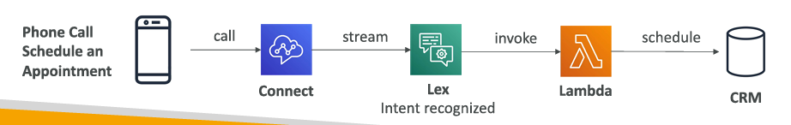

Textract: detect text and data in documents
- Converts hand written text, data(aadhar card, invoices, bills) into standard documented info.

Summary:
- Polly speaks
- Transcribe listens
- Lex talks and understands – to build chatbots
- Comprehend reads and analyzes – NLP
- Connect: Virtual contact center
- SageMaker: machine learning for every developer and data scientist to build ML models
- Forecast: build highly accurate forecasts
- Kendra: ML-powered search engine
- Personalize: to built “real-time personalized recommendations” feature in applications
- Textract: detect text and data in documents and extrac the information

DNS

Route 53
Fully managed and Authoritative DNS
Record Type
A – for Ipv4
AAAA – Ipv6
CNAME – Domain name(Don’t have an IP actually) points to another Domain name
Alias – Domain name points to AWS service
Hosted Zones
Public hosted zones – contains DNS registers which public can access
pvt hosted zones – contains DNS registers which only private components can access

DNS TTL – Time for which the IP will be mapped to the Domain name in Local Cache

DNS based load distribution
Forwarding traffic – by choosing IP based on policy
- Diff:
  - Load balancer – chooses how requests are handled
  - Route 53 – chosses which server handles the request
- Route policies:
Policy | What it does
Simple | One endpoint
Weighted | Split traffic by %  (Individual weight/ overall weight)
Latency | Lowest latency region
Failover | Active-passive  1 primary server  Then secondary server  - Forwarded based on Health checks
Geolocation | Based on user’s country
Geoproximity | Based on region + bias
Multi-Value | Return multiple healthy IPs

Traffic Flow
- To Combine Policies, 1+ route policies implemented in Decision tree using Traffic flow

Domain Registrar – DNS Service + External 3rd party services
I can buy Domain name www.example.com from Godaddy(Domain Registrar) and integrate it with Route 53 from AWS by updating route 53 name servers in Godaddy to manage the DNS service.
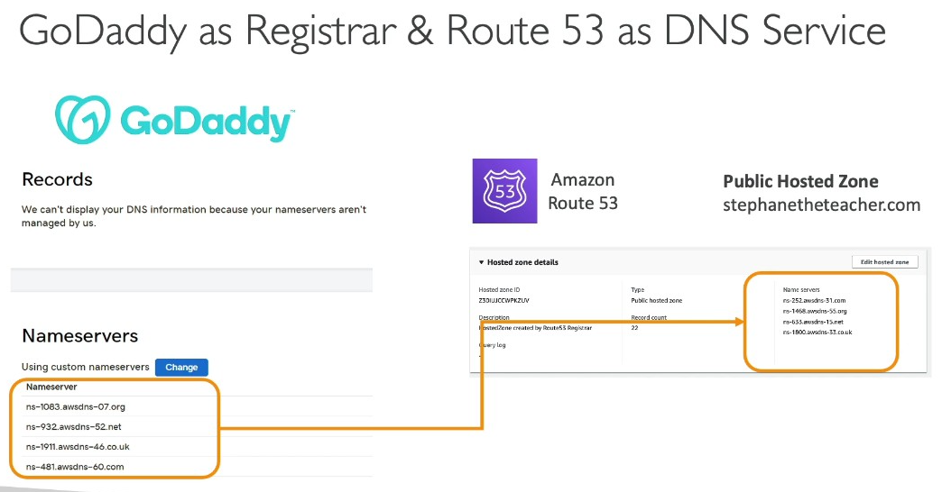

ArChitecture

Arch 1
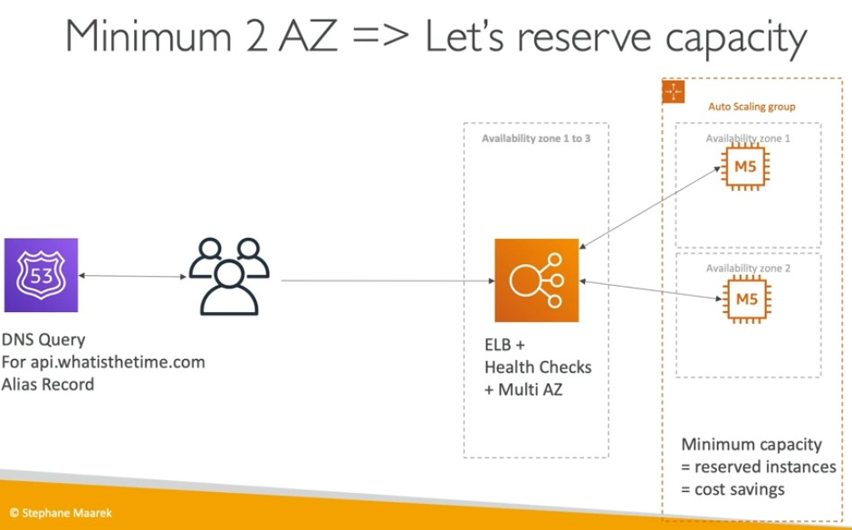
Route 53 recommends IP to load balancer from 3 AZ based on Geo proximity policy, Based on health & latency
Load balancer forwards the request to instance in MAZ
Cost reduction: reserve 1 instance per AZ; min 2AZ
- Scaling: On Demand Instances can scale based on the traffic

Arch 2
Stateful applications:
If incase the application server fails/goes down, the entire data in state will be lost
To avoid such cases, we have to keep the application servers Stateless as possible
- States will be managed with Cache

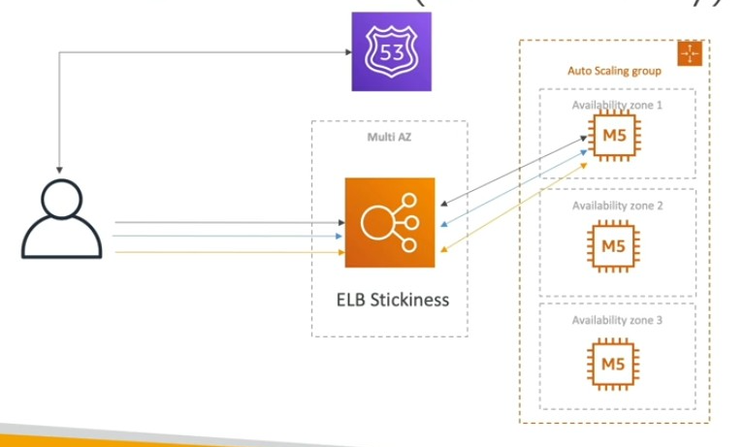
User Cart data is stored in an instance
- to keep the user and the specific server intact, we’re using stickiness bw user and server.
- Stateful session
But if the server goes down, still the user loses all the cart data.
- So the session has to be stateless

Hence cart data can be with user [Cookies]
- Which makes the request heavier
So cart data will be stored in ElastiCache. user sends the session Id with which server retrieves users cart data from cache
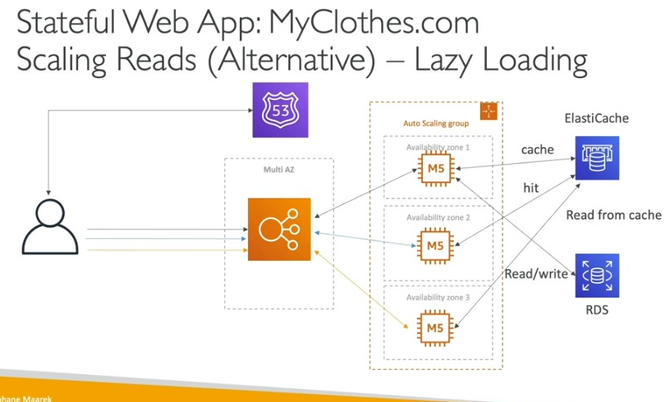
- Session Id will be sent in HTTP request
RDS will be serving as DB. To avoid read overload
- we’ll have read replicas with one master RDS manages rw and other replicas manages reads
To manage the request flow among this arch, we’ve
- Security groups

Security Groups arch:
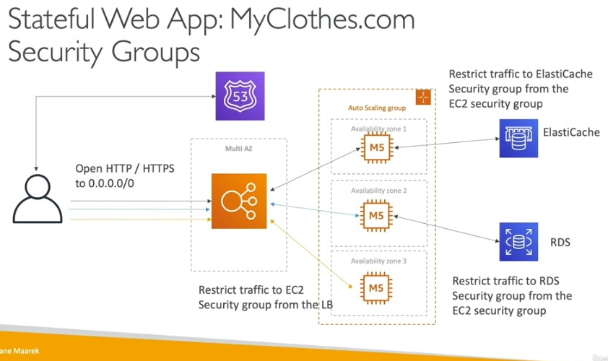

Arch 3
EBS -> EFS
When big data is stored in one servers EBS that can’t be accessible through other server. So,
- In large scale of Instances – all are mapped to 1 EFS through ENI
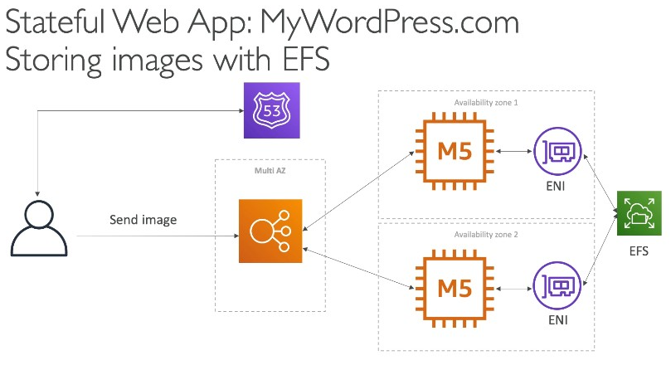

Elastic BeanStalk
- Collectively handles all the components(EC2, Autoscaling, load balancer, storage,..) by itself
- Environments: Dev, Testing, Staging, Prod

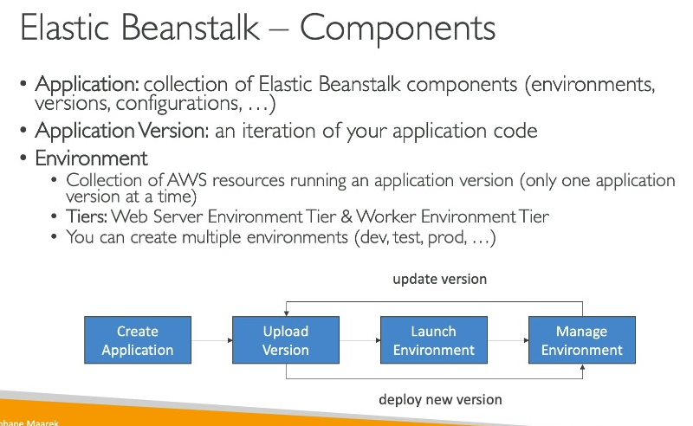
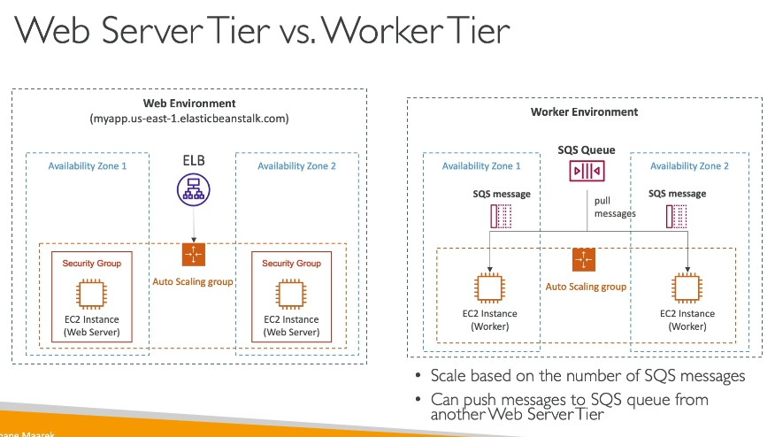

Cloudfront & AWS Global Accelerator

DeCoupling applications

Containers

Serverless
- No need to manage the servers(no provisioning)
Compute – AWS Lambda, AWS API Gateway
Containers – ECS Fargate
Authn – AWS Cognito
Storage – S3
Database – SQL:Aurora, NoSQL: DynamoDB
Others – SNS, SQS, Kinesis

AWS Lambda
Pay per request and compute time
Free tier: 1st 1Million reqs, 4L GB-secs of compute time
Cost tier: 0.2$ per 1M reqs, 1$ for 6L GB-secs
Total cost = cost(reqs) + reqs*cost(GB-secs)
- Max RAM available per function: 10GB Ram
- Supports:
  - Containers with Lambda Container Image + Lambda runtime API
  - many mainstream languages + other languages are community supported
Limits:
Memory – 128 MB to 10GB RAM
Disk – 0.5 to 10 GB ROM
Max execution time: 900s
Envt variable size: 4KB
Deployment size: 250MB or 50MB(Compressed deployment)
Concurrency : 1k reqs per region; per function concurrency limit should be set to avoid throttling.
For concurrency to be achieved: 100 reqs at a time, 100 envts have to run parallely.
Cold Start & Provisoned concurrency:
- cold start: lambda creates a new environment when it receives request for the first time, then the envt will be reused for the subsequent requests.
  - Cold start takes more time i.e, 2s
  - To avoid cold start: Provisioned concurrency
- Provisioned concurrency = 50
  - Keeps 50 envts ready all the time to serve requests.
Async Invocations: enabling async invocations will put the exceeding reqs (after 1k) in queue and retry executing the req for the next 6 hours (from 1 sec once to 5 mins once)
Snapshot of Lambda function: takes and retains snapshot of Mem & Disk state of initialized lambda function, directly goes to the invoke state skipping init state.
- w/o snapshot: init invoke shutdown
- with snapshot: directly invokes.

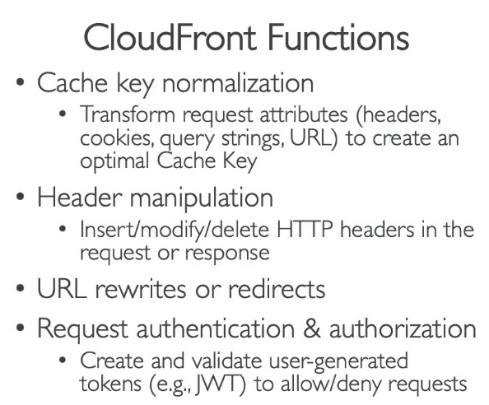
Customization at edge(Lambda functions at edge)
2 kinds:
- Cloudfront fns – lightweight
- million no. of reqs per seconds, <1ms per req.
- ❎no nw access or fs access
- Lambda@edge – heavyweight
- Thousands of reqs per secs, 5 - 10s per req.
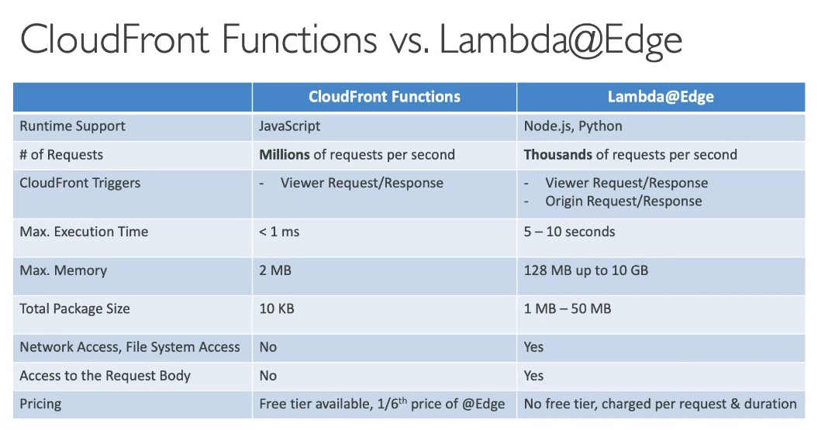
VPC for Lambda: Create ENI for a lambda function in a pvt subnet, so that lambda could access all the resources in the subnet.
Lambda to RDS Connection:
Issue: 1000s of lambda functions accessing the RDS DB directly too many open connections timeout errors.
Soln: RDS Proxy – manages the connection pool, IAM authn can be setup to enhance security.
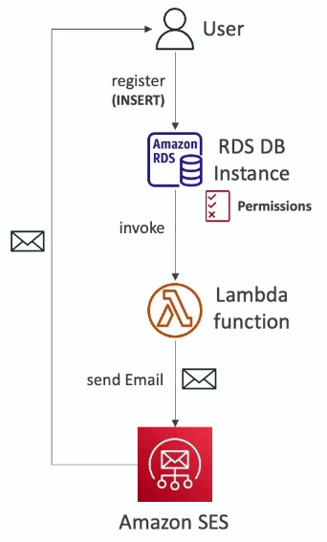
Invoking Lambda from DB(RDS PostgreSQL & Aurora)
- Any data update in DB can be used to invoke Lambda function.
- RDS Event notifications – used to notify any activity/Event in DB to the subscribed user.

Monitoring & Observability

Monitoring – Cloudwatch
Metric
Dimension – attribute(instance id, envt) to a metric, upto 30 dims per metric
Cloudwatch streams --(data)-- Data firehose Data storage(S3), Data warehouse(Redshift, S3 + Athena), search and analyse logs(Opensearch), 3rd party services(Datadog, New relic, Dynatrace,splunk,..)
- In streams metrics can be filtered(only the reqd metrics) and streamed.
CloudWatch Logs
└── Log Group: /aws/eks/production-app
├── Log Stream: pod-1
└── Log Stream: pod-2
- Can be retained as long as we want(upto 10 years)
- Encrypted by default, encryption available with KMS

Cloudwatch | Cloud Config | Cloud Trail
Monitor metrics, logs, resource usage | Monitors configurations of and around a resource  Eg: loadbalancer configurations and it’s security group’s configurations | Monitors the api calls within an account from AWS SDK, CLI, Console, IAM User & roles
Manages alarms and events based on the metrics | Evaluate resources against compliance | To identify who made any changes in the resources

IAM Advanced

Security & Encryption

Networking – VPC
Levels:
VPC
VPC level – attached to all the Instances in the VPC
Component – EC2: Hosting the Application

Subnet
Subnet level - attached to all the Instances in the subnet
Component level - attached to individual instances
Application level
VPC – CIDR Block
Subnet
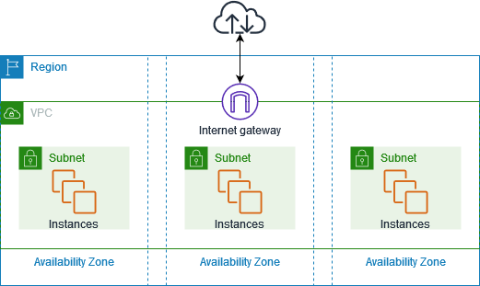
Subnet
- Subnet routing: Each subnet is associated with a route table.
- Firewall: NACL – Denies everything by default
- External Connectivity Gateway:
  - Pub subnet use – Internet GW
  - Pvt subnet use – NAT GW
Route Table: decides where packets go (internet, NAT, peering IPs, etc.).
- Attached to subnets – routes traffic from subnet -> Target -> Destination
Source | Destination | Target
Subnet | IP/ IP range | Gateway – external connectivity  Local – internal connectivity
Gateway → Provides connectivity outside their local/pvt IP space
Kinds:
- Internet GW – to connect to internet
- NAT GW – private subnets/resources to connect to internet
- ‘outbound-only’, based on the state memory, NGW allows responses only which are originated from the pvt subnet
- Transit GW – a hub for connections between VPC1, VPC2, VPN, On prem DX to connect among themselves.
- VPC Endpoint – to connect AWS Services internally(internal AWS pvt network)
these all ok to send and receive requests & responses but how we execute terminal level commands in our remote server ?
- SSH
SSH: Secure SHell
- To connect to remote server terminal(shell)
- Secure = Encryption + Authentication(key-pair) + Integrity(Message auth code(MAC))
Adie: ok no offense but where do they live ? what about their consistency and reliability ?
- They are AWS-managed, distributed networking components in the VPC fabric inside infrastructure(abstracted from clients).

Security Group → instance-level firewall (stateful).
SG Vs NACL
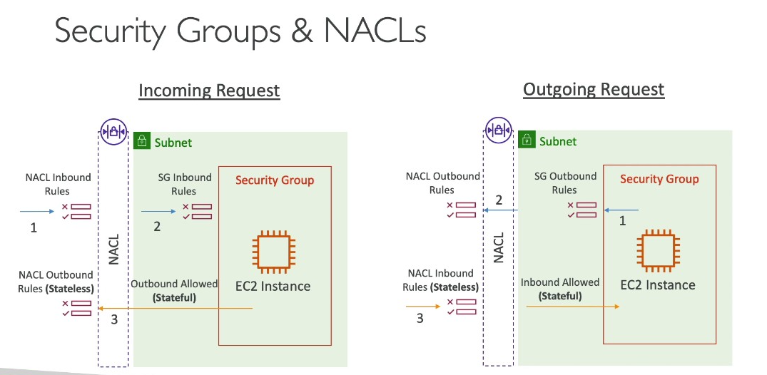

NACL
- Each NACL rule has rule number, with lower number == higher precedence

Ephimeral Port
Client and server will communicate on the ‘client port’ client specified at first request

VPC Peering
- 2 VPC networks connected across different account/diff region – to behave the same as 1 VPC
- Routing can be done from one VPC to another by specifying the Account Id (provided both the VPC in same region)

Connectivity
Hybrid Connectivity: Connecting On prem network with AWS VPC network
AWS Site – Site VPN: public connectivity with IPSec encryption bw on premises nw to AWS VPC network
AWS Direct connect: dedicated private connectivity(not encd by default) bw on premises nw to AWS VPC network
Direct connect Gateway - Setup Direct connect to many VPCs in different AWS regions
VPC Peering Connection: connects 2 VPCs through AWS network
- 2 VPC networks across different account/diff region connected – to behave the same as 1 VPC

Resource connection: Suppose VPCB wants to access a service from VPCA, instead of peering the entire network VPCA VPCB, we can use endpoint: exposes a specific service from network
VPC Endpoint – to connect AWS Services internally(through internal AWS pvt network rather than internet)
├── Gateway Endpoint: creating Gateway endpoint for the mentioned services, AWS updates the route table forwarding the traffic from EC2 to S3 through AWS internal network, rather than using internet. Only for: S3, DynamoDB
│
└── Interface Endpoint
├── AWS Services: creates an ENI IP for AWS managed services i.e, Secrets manager and places it in the same subnet as EC2.
└── PrivateLink Services: to connect with not AWS managed services

VPC EndPoint
- To connect to AWS services
  - IAM role’s attached to server – providing server the required access to connect to AWS service.
- Route:
From | Destination | Target
Our servers | AWS Service | VPC Endpoint

- Endpoint Kinds:
  - Interface –
    - Works on subnet level
    - Attached to SG
  - Gateway(free) – only for DynamoDB and S3
    - Used as a target in route table
    - Works on VPC level
VPC Flow Logs
- Logs VPC networking and data flow – logs by ACCEPT and REJECT action status
  - In Cloudwatch
  - In s3 + Athena
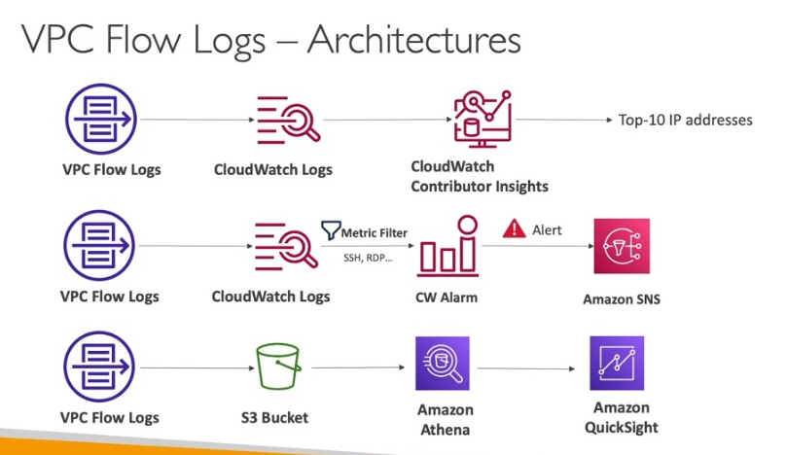

VPC Mirroring
- For deep visibility into network packets we can setup VPC mirroring
- VPC mirroring - copies traffic from source instance and send it to destination(implemented with security tool)
- Use case – content detection, threat detection, troubleshooting
Networking Costs
Ingress traffic  (outside to AWS) | Requests coming into our network |  | Free of cost
 | Intra region
 | Intra AZ |  | foc
 | Inter AZ | Bw public IPs | 0.02$
 |  | Bw private IPs | 0.01$
 | Inter region
Egress traffic  (from AWS to outside) |  |  | costly

Try to keep as much as traffic within the AWS network – less costly
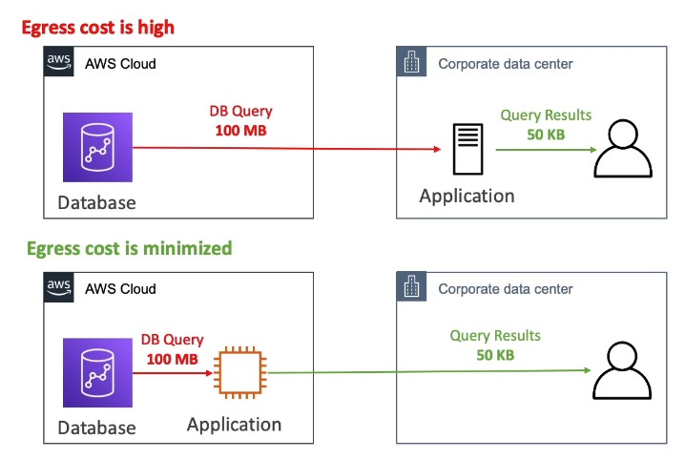

Summary:

Disaster Recovery & Migrations

Architectures II

Automation in AWS with Python + Lambda + serverless
Automation

Miscellaneous

GraphQL
RW data in Backend APIs in Json format
- With API, we obtain only one entity per request
  - To get maximum data – we use GraphQL
  - GraphQL requests data in Json format

Resolver
- Resolves the request(by fetching/computing answer to the request)

Streams
- For async jobs

SNS
Endpoints supported by SNS: Email, SMS(Mobile push notifications), SQS, Lambda, HTTP/HTTPS endpoints

SQS
SQS triggers ASG based on the metric: “ApproximateNumberOfMessagesVisible”
SQS Standard Queue: Delivery – processed atleast once(duplication may possible)
SQS FIFO Queue: Delivery – processed only once
- Supports 300 message operations p/s

SQS Vs Kafka:
Queue – for simple streaming jobs
Kafka – multiple consumers consumes the same event
- retains events
  - for analytics purposes
  - consumer mishandling the event event can be replayed to correct the mishandling.
Versus
SQS:
Many producers(messages) → Queue/s → Many consumers
- Each message is consumed by only one consumer.

Kafka:
Many producers(events) → Topic/s → Many consumer groups
- The same event can be consumed independently by multiple consumers.

SAA-C03 Knowledge(Practice Questions)

Network

Entry Point
API Gateway
- Kind of APIs supported: Rest API, HTTP, Websocket

Data Analytics

Kinesis Data Analytics
- End to End stream processing application for real time analytics, IOT,..
Use cases:
- Streaming ETL, continuous metric generation, responsive real-time analytics, and interactive querying of data streams

Interview Preparation
- How to design a Highly available and highly scalable multi tier architecture
- AWS NAT
  - NAT – initiates internet connection for our private servers that way, our private servers can send requests to internet but can’t be reached in(the source IP is replaced by NAT’s public IP).
- Can different subnets communicate to each other by default ?
  - Default route table routes the requests to the destination(VPC CIDR) through the target(Local) which enables subnet-subnet communication.
- NACL vs SG
  - NACL – on subnet level, with lower number NACL rule has higher precedence.
    - Stateless
    - NACL by default denies everything
  - SG – on instance level
    - Stateful
- EC2 instance terminated Unexpectedly
  - Check cloudtrail for api calls regarding “terminate instance”
- 🚩Lambda function fails randomly. How this can be resolved ?
  - Enable tracing using AWS X-Ray to findout where it’s failing
  - Call latency – check
    - If lambda function is failing due to latency(timeout) -> increase the timeout
  - Increase Retries(as an immediate action)
  - Check code quality and update the code
- What will you do when RDS storage is full ?
Immediate actions:
  - Increase storage through AWS CLI
aws rds modify-db-instance \
--db-instance-identifier mydbinstance \
--allocated-storage 200 \
--apply-immediately
  - Check temporary files, transaction logs
  - Clean up space – check DB, Table - drop unused Tables, indexes

To avoid reccurrence of the issue:
  - Enable Storage autoscaling
  - Configure cloudwatch alerts
    - Metric: FreeStorageSpace<10% --> notifies
  - Regular housekeeping has to be performed to manage the storage space

- Take Snapshot in AWS:
aws rds create-db-snapshot \
--db-snapshot-identifier mydb-snapshot-20260404 \
--db-instance-identifier mydbinstance

- Developer Deleted Critical Resources like S3, RDS and EC2. What will you do ?
  - Recover the instances:
    - EC2 recreated from Golden AMI
    - EBS recovered from Snapshot
    - RDS from Point In Time(or)Daily backups
EBS & RDS takes incremental backups.
    - S3 from past versions
  - If we have our IAC with the backups integrated, we can redeploy IAC infrastructure to recover the lost components.
  - Least/Zero Privilige – remove ‘delete resource rules’ from the IAM.
- Cost optimization activity
  - Written 1 Lambda function(runs periodically) to reclaim unused EBS volumes.
  - Written lambda function to upgrade the EBS volumes from GP2 to GP3
- 🚩Real World Challenge
- 🚩Service used Day2Day
- ASG not launching EC2. Wyd ?
  - Check the launch template. Check if the AMI, Instance type is valid
  - Check subnet and AZ
  - Check IAM policy assigned to the ASG.
  - Check EC2 Quota
- Issue with EFS: Mount target unreachable due to mount failing
Troubleshooting:
  - Check if EFS is accessible from other Azs
  - Check EFS SG, IAM
- EBS Vs EFS
  - EBS over EFS:
    - Directly attached to EC2 -> Low latency -> High IOPS
      - Best for manual DB setup
  - EFS:
    - Autoscaling, shared storage.
- How to remove console access in AWS
  - In Terraform: remove aws_iam_user_login_profile leaving the iam_access_keys alone
  - In console: go to IAM security credentials and delete console sign in password leaving the Access keys, gives the user CLI access alone.
- How Lambda function from AWS Account A connects to S3 in AWS Account B
  - S3 Buckets are universal we can just use AWS account B arn to connect.
    - Jus to make sure, the lambda function has proper access policy
- AWS Cross account connection(AWS acc A – AWS acc B)
  - STS – Security Token Service - To provide One time/ Temporary access to AWS services through IAM role.
  - Trust Policy - Restrict access to specific users/roles
  - AWS Account A:
    - Lambda function uses STS of ‘A’ which assumes role of ‘B’, connects and fetches data from DynamoDB ‘B’
  - AWS Account B:
    - IAM role in ‘B’ uses trust policy to accept acc ‘A’ with it’s ARN.
- AWS Secrets manager Vs Systems manager Parameter store
  - Systems manager Parameter store – Basic reqt
    - Automatic password rotation
    - Cross account password sharing
  - Secrets manager – Adv reqt
- Day2Day activities related to Databases
  - Day2Day activites mostly associated with Monitoring:
    - Checking if DB usage is normal, checking DB consumption
    - Taking snapshots before deployments
- Lambda functions Day2Day activities:
  - Cost optimization
    - Retrieving unused/unattached EBS volumes
  - enforcing organization compliance
    - checking tags for resources

